COMP3000

Computing Project

2022/2023

Project Initiation Document

Contents Page:

Introduction 3

Project Title 3

Links 3

Project Vision 3

Risk Plan 4

Proposed Gantt chart 6

Keywords 6

# **Introduction**

This Project Initiation Document will provide insight into the project. It sets out a structure explaining what actions are carried out in the implementation phase of the project and the decisions made on why the actions are performed. It will provide the baseline of how the project will be managed and an understanding of its success.

# **Project Title**

FaceCCTV

# **Links**

GitHub Repository (source code): <https://github.com/Parker06/COMP3000-FaceCCTV>

# **Project Vision**

After doing research on the crime rate percentage and seeing a 1% increase of crimes committed in 2021 from 2020 to approximately 79,000 in the last 12 months and only a 5% of those result in a charge. You wonder why? This is partly due to the poor quality of CCTV, which makes finding the right person more difficult. Adding to this, higher-resolution cameras are on the expensive side which most businesses can’t afford, due to high costs or budget restrictions, resulting in them purchasing lower-resolution CCTV cameras which could lead to poor image quality. If you ever tried to upscale an image, it will become very pixelated and may require photo editing skills to do it professionally, which potentially adds to the costs.

My solution is an app called FaceCCTV, where users can upload an image then the app uses deep learning AI (trained beforehand with a dataset of pre-collected images). the AI can detect the faces in an image and then enhance the faces, which the user can export and use later on. The main goal is to provide a tool that is easy to use and powered by AI to help people identify criminals easier without the unnecessary costs of cameras or professionals.

# **Risk Plan**

There should not be any identifiable risks when developing the minimum viable product. However, as we increase the complexity of the project, the risk level will increase. At this point in time, I am very familiar with front-end development so there’s a lot of variety that I could use. On the other hand, when it comes to the AI functionality of the project there are some techniques that will be used that I am less knowledgeable about.

In preparation for this project, research has been thoroughly carried out, such as what frameworks and languages to use as a backup plan in the scenario where it becomes difficult to execute the required aspects with the initially intended tech stack.

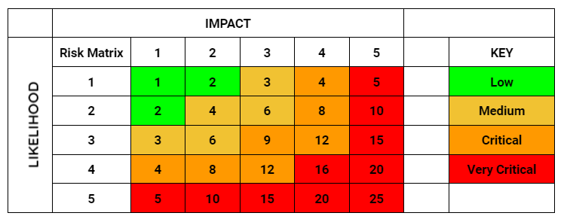

The table above is a risk matrix which presents how I can calculate a risk score for each risk to the project. Below is a table where it shows a risk, its risk score and the solution.

| Risk | Score | Level | Solution |
| --- | --- | --- | --- |
| AI not performing optimally | 16 | Very Critical | The AI should be given enough test data to train so that the error rate is reduced to a reasonable percentage. |
| Poor Time Management | 9 | Critical | To make use of the Gantt Chart created to track the sprints and time management relative to the progress made. |
| Performance Quality | 9 | Critical | Making sure that the code is written efficiently enough to ensure the tasks of the software are executed without performance issues. |
| Tech Stack Unfamiliarity | 9 | Critical | Research the different technologies, read the various documentation and if not then have additional plans to use other familiar technologies. |
| Understanding the complexity of the project | 6 | Medium | Make sure that I understand the goal(s) of the project clearly without going too far out of scope and stick to the requirements based on the user stories. |
| Data Loss | 4 | Medium | The code and the project’s assets should be regularly committed to a version control environment. |

# 

# 

# **Proposed Gantt chart**

This Gantt chart displays briefly how the project workflow (the separate work stages and how they fit together) will look during the project’s development lifecycle in a high-level outlook.

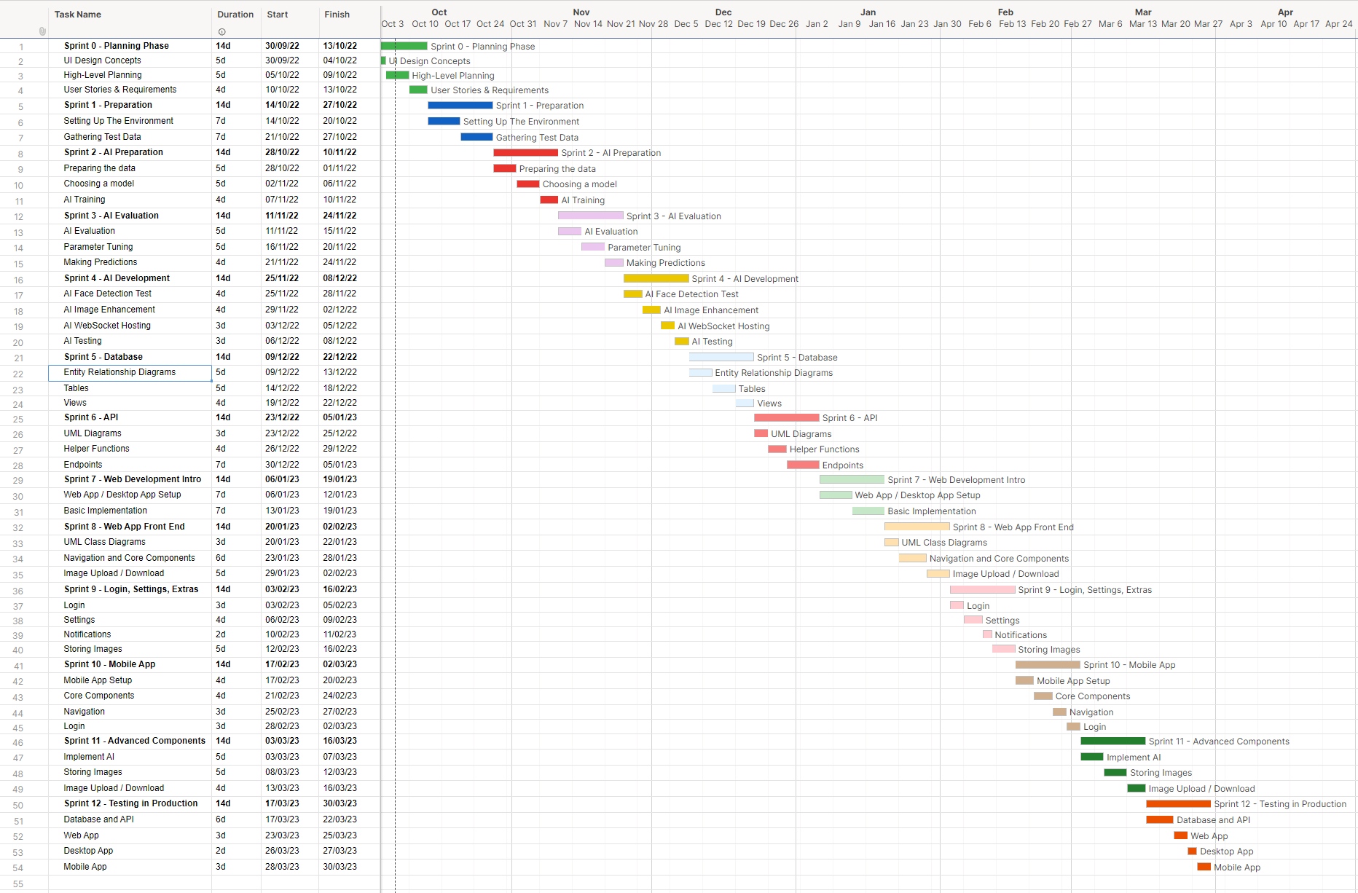

# **Keywords**

These are the keywords that will be used to label the project when searching for it:

* AI, Facial Recognition, Security, CCTV, HTML, CSS, JavaScript, React, Python, Harry, Parker, Deep Learning, Image Enhancement, Face Detection